Sample template. The author names are placeholders; replace the contact details and institutions with your own. The equations and illustrative numbers demonstrate formatting and are not results of a verified study. Replace the demo material and delete this line before submission.
UDC 004.383.3
Smirnov P. I.¹, Petrov A. V.¹
1[Full institution name], [City, Country]
SAMPLE ARTICLE FORMAT: LOAD BALANCING IN A CLOUD CLUSTER
Abstract. This sample demonstrates the presentation of an article about request distribution in a cloud cluster. It addresses the need to keep workload indicators, mathematical notation, and comparative results consistent throughout a scientific manuscript. The purpose is to illustrate a structure containing a problem statement, equations, a code fragment, a figure, a table, and a discussion of limitations. The example uses an illustrative workload model that combines processor, memory, and input/output utilization ratios. A second linear index combines normalized queue length, normalized queue change rate, and processor utilization. The code fragment demonstrates only the arithmetic calculation of this index for specified inputs and weights. An illustrative dataset represents three load balancing strategies. Their mean response times are 145, 110, and 65 milliseconds, respectively; the same values appear in the figure and the table. The table also includes examples of the ninety-ninth latency percentile, error percentage, and processor utilization. These numbers were not obtained experimentally and do not establish the superiority of any strategy. The example distinguishes descriptions of reported indicators from conclusions requiring additional evidence. It discusses input normalization, explicit weights, measurement conditions, and repeatability. The material can serve as a manuscript formatting guide. Its model and data are educational; before submission, authors must replace them with their own reproducible research and supported conclusions.
Keywords: load balancing, cloud cluster, load index, request queue, response time, article formatting.

Introduction
This sample shows how to format an article, using request distribution in a cloud cluster as an example. General principles of distributed systems are presented in [1]. Consistent hashing is used to distribute keys among nodes [2]; practical aspects of working with Kubernetes are discussed in [3]. Microservice architecture is the subject of [4], and data storage and processing are covered in [5]. Paper [6] is given as an example of a conference publication on attention mechanisms: such models are not used in this demo calculation. The difference between mean and high-percentile latency is discussed in [7]. These sources provide context and citation examples; they do not confirm the illustrative numbers below.
Fig. 1 shows the illustrative mean response time for three load balancing strategies. The values match Table 1 and are intended only to demonstrate how comparable data are presented.
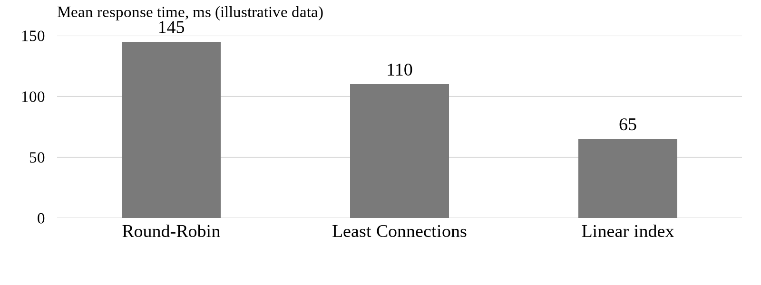
Fig. 1. Mean response time for three load balancing strategies: illustrative data

Materials and Methods

Examples of load index calculation
To demonstrate how equations are written, two dimensionless indices are considered. They illustrate the formatting of calculations and do not by themselves define a request routing rule.
The load calculation takes into account the following indicators:
- current processor and memory utilization;
- input/output operation rate;
- request queue length and its rate of change.
Equation (1) expresses the current load index. The CPU utilization ratio is squared, while the RAM and IOPS utilization ratios enter linearly. All ratios are dimensionless; their denominators must be positive.
The current load index is defined as follows:
$L_{current}=α∙{\left(\frac{{CPU}_{used}}{{CPU}_{total}}\right)}^{2}+β∙\frac{{RAM}_{used}}{{RAM}_{total}}+γ∙\frac{{IOPS}_{cur}}{{IOPS}_{max}}$, | (1)
where $α$, $β$, and $γ$ are non-negative dimensionless weights that sum to one; ${CPU}_{used}$ and ${CPU}_{total}$ are the used and available computing capacity; ${RAM}_{used}$ and ${RAM}_{total}$ are the used and available memory; ${IOPS}_{cur}$ and ${IOPS}_{max}$ are the current and maximum input/output operation rates.
The second example is a linear load index that takes the queue state into account:
$L_{score}=β_{1}·Q_{t}+β_{2}·ΔQ_{t}+β_{3}·{CPU}_{t}$ | (2)
where $Q_{t}$ is the queue length divided by a specified positive reference length; ${ΔQ}_{t}$ is the queue change rate divided by a specified positive reference rate; ${CPU}_{t}$ is the processor utilization ratio; $β_{1}$, $β_{2}$, and $β_{3}$ are non-negative dimensionless weights that sum to one. ${ΔQ}_{t}$ can be negative when the queue is shrinking. The reference values, weights and measurement interval are chosen and described by the author of the study. Equation (2) does not set a forecasting horizon and does not predict hardware failure.

Example of a software calculation
Listing 1 shows the calculation of the linear index according to Equation (2). The parameters q, delta_q and cpu correspond to its normalized inputs, and beta contains the three weights. Preparing the input measurements and choosing the weights are outside the scope of this short example.
Listing 1 – Calculating the linear load index in Python
def load_score(q, delta_q, cpu, beta):
b1, b2, b3 = beta
return b1 * q + b2 * delta_q + b3 * cpu

Results
Table 1 shows illustrative values that demonstrate how comparison results are presented. They were not obtained in the described experiment and cannot be used to assess the performance of the algorithms.
Table 1 – Illustrative comparison of load balancing strategies
Balancing algorithm | Mean response time (ms) | 99th percentile (ms) | Error rate (%) | CPU utilization (%)
Round-Robin | 145 | 1250 | 2.4 | 85
Least Connections | 110 | 850 | 1.1 | 78
Linear index | 65 | 320 | 0.05 | 92

Discussion
In the illustrative dataset, a lower mean response time is accompanied by a lower 99th percentile and error rate. CPU utilization, however, changes non-monotonically. These indicators describe different aspects of system behavior; without additional measurements, they cannot establish reduced resource consumption or improved resilience. A real article should describe the comparison conditions, the repeatability of measurements and the uncertainty of the results.

Conclusion
The example shows how equations, a code listing, a figure and a table are formatted together with consistent notation and numerical data. The values presented are illustrative. Scientific conclusions about load balancing require your own reproducible measurements, a justification of the chosen model and a discussion of limitations.

References
- van Steen, M., & Tanenbaum, A. S. (2017). Distributed systems (3rd ed.). distributed-systems.net. https://www.distributed-systems.net/index.php/books/ds3/
- Karger, D., Lehman, E., Leighton, T., Panigrahy, R., Levine, M., & Lewin, D. (1997). Consistent hashing and random trees: Distributed caching protocols for relieving hot spots on the World Wide Web. In Proceedings of the twenty-ninth annual ACM symposium on Theory of computing (pp. 654–663). Association for Computing Machinery. https://doi.org/10.1145/258533.258660
- Burns, B., Villalba, E., Strebel, D., & Evenson, L. (2019). Kubernetes best practices: Blueprints for building successful applications on Kubernetes. O’Reilly Media.
- Newman, S. (2021). Building microservices: Designing fine-grained systems (2nd ed.). O’Reilly Media.
- Kleppmann, M. (2017). Designing data-intensive applications: The big ideas behind reliable, scalable, and maintainable systems. O’Reilly Media.
- Vaswani, A., Shazeer, N., Parmar, N., Uszkoreit, J., Jones, L., Gomez, A. N., Kaiser, Ł., & Polosukhin, I. (2017). Attention is all you need. In I. Guyon, U. von Luxburg, S. Bengio, H. Wallach, R. Fergus, S. Vishwanathan, & R. Garnett (Eds.), Advances in neural information processing systems (Vol. 30, pp. 5998–6008). Curran Associates. https://proceedings.neurips.cc/paper/2017/hash/3f5ee243547dee91fbd053c1c4a845aa-Abstract.html
- Dean, J., & Barroso, L. A. (2013). The tail at scale. Communications of the ACM, 56(2), 74–80. https://doi.org/10.1145/2408776.2408794

Information about the authors
Smirnov Petr Ivanovich — [position], [academic degree and title, if any], [full institution name], [city, country], e-mail: author1@example.org
Petrov Alexey Vladimirovich — [position], [academic degree and title, if any], [full institution name], [city, country], e-mail: author2@example.org

